**Name: Mahin Prakash**

**Prime Video Dataset Insights**

1. Many titles which happens to come under the “Movies” type are more than “TV Show” type

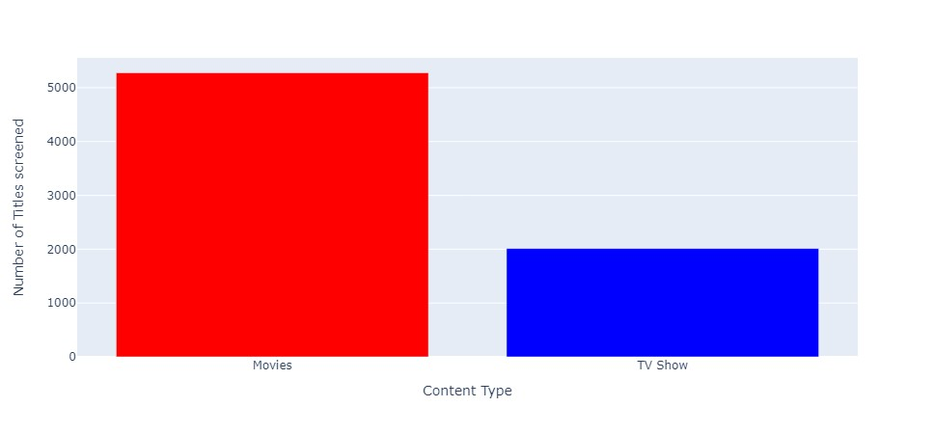

2) Most of the titles belong to the “TV-MA” rating

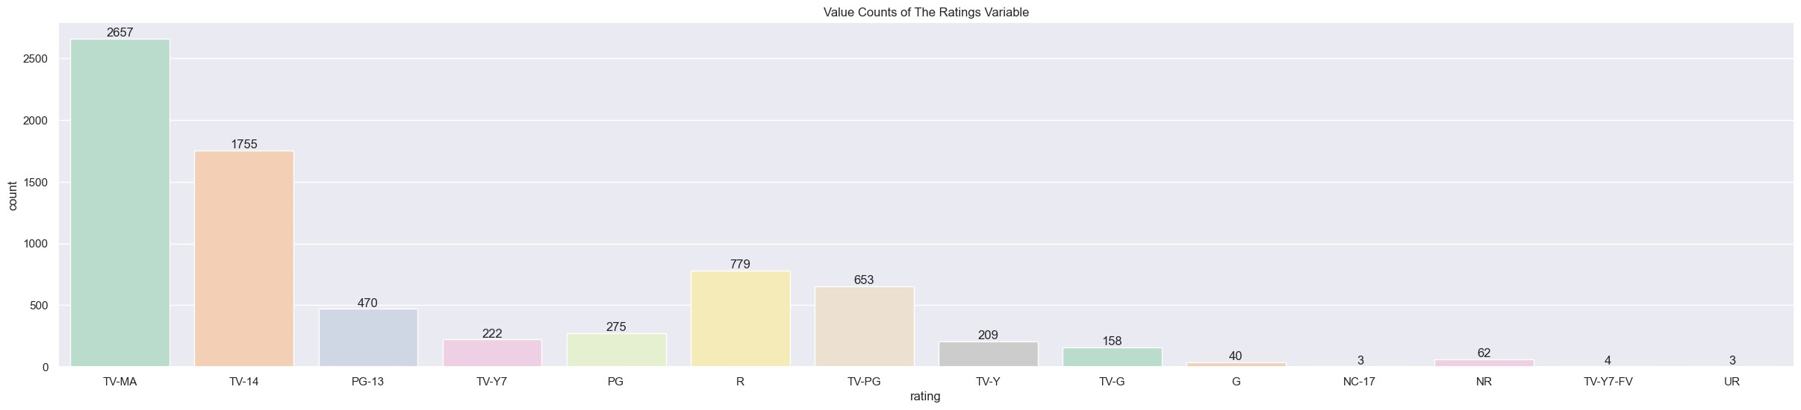

3) 2018 was the year in which many titles were released

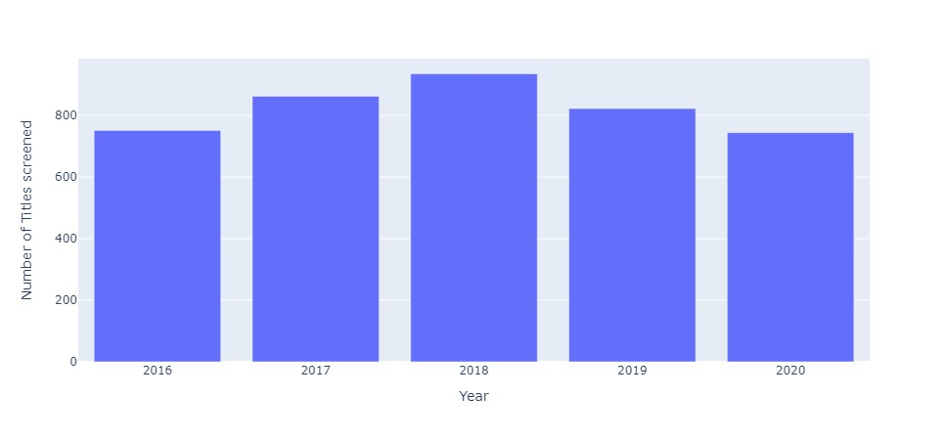

4) Titles which has screened in more than 5 countries

'Sankofa',

'Shaun the Sheep',

'The Professor and the Madman',

'The Take',

'Wadjda',

'Arctic Dogs',

'The Danish Girl',

'The Command',

'Ultimate Beastmaster',

'Beyond Skyline',

'A Sort of Family',

'Another Forever',

'Domino',

'Frozen Planet',

'Frozen Planet: On Thin Ice',

'Frozen Planet: The Epic Journey',

'Nymphomaniac: Volume II',

'The Breadwinner',

'The Congress',

'The Making of Frozen Planet’